***WD - Bootstrap Basic & Advanced***

1. What are the advantages of Bootstrap?

Bootstrap, a popular front-end framework, offers several advantages that contribute to its widespread use in web development:

***Responsive Design***: Bootstrap provides a responsive grid system that adapts to various screen sizes.

***Pre-built Components*:** Bootstrap includes a wide range of pre-designed components like navigation bars, modals, carousels, forms, and more..

***Consistent and Professional Look***: Bootstrap's design principles and components help create a consistent and professional appearance across different parts of a website.

1. What is a Bootstrap Container, and how does it work?

In Bootstrap, a container is a fundamental building block used to wrap and contain the content of a web page. It helps in providing structure, responsiveness, and consistent spacing for the content within it.

Container:

The standard container, denoted by the class container, provides a fixed-width container. The width of the container remains constant regardless of the screen size, and it doesn't change as the viewport size increases or decreases.

1. **What are the default Bootstrap textsettings?**

**Bootstrap provides several utility classes for styling text elements. These utility classes make it easy to apply various text-related styles without the need for custom CSS.**

***Text Alignment:***

**text-left: Align text to the left.**

**text-center: Center-align text.**

**text-right: Align text to the right.**

**text-justify: Justify text.**

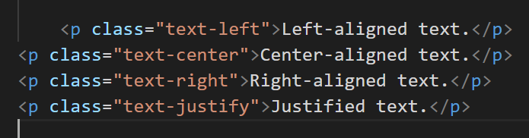

1. **What do you know about the Bootstrap Grid System?**

**Grid Structure:-**

***Container*:**

**The outermost element that wraps the entire content. It is used to create a fixed or fluid-width layout.**

***Row:***

*A container for columns. Rows are used to ensure proper alignment and spacing.*

*Example:*

1. ***What is the difference between Bootstrap 4 and Bootstrap 5***

***CSS Flexbox as the Default***:

Bootstrap 5 switched to using CSS Flexbox as the default layout model instead of the previously used CSS float. This change enhances the flexibility and responsiveness of layouts.

***jQuery Dependency***:

Bootstrap 4 relied on jQuery for certain interactive components, such as dropdowns and modals. Bootstrap 5, however, has removed this jQuery dependency, aiming for a more lightweight and modern approach

***Customization with Sass:***

While both Bootstrap 4 and Bootstrap 5 use Sass (Syntactically Awesome Stylesheets), Bootstrap 5 provides more options for customization. It has an improved and modular Sass file structure, making it easier for developers to customize and extend the framework.

***New Utility Classes:***

Bootstrap 5 introduced several new utility classes for spacing and sizing elements, making it more convenient for developers to handle spacing and layout adjustments.

1. **What is a Button Group, and what is the class for a basic Button Group?**

***A button group in Bootstrap is a group of buttons that are visually connected and typically used to perform a related set of actions. Button groups help in organizing and styling multiple buttons together…***

1. **How can you use Bootstrap to make thumbnails?**

***In Bootstrap, thumbnails are typically created using the card component to provide a container for images along with optional titles, text, and other content. The card component is versatile and allows you to create visually appealing thumbnail-style elements.***

1. ***In Bootstrap 4, what is flexbox?***

***Flex Container:***

**The parent element containing one or more flex items is known as the flex container. In Bootstrap, the .d-flex class is often used to turn an element into a flex container*.***

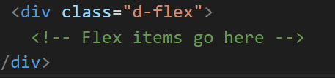

1. **How can one create an alert in Bootstrap?**

**In Bootstrap, alerts are used to communicate important information to users. They are visually distinctive and often used to notify users about successful actions, warnings, errors, or informational messages..**

1. **What is a bootstrap card and how would you create one?**

**Bootstrap card is a flexible and extensible content container that allows you to group various types of content, including text, images, links, and more. Cards in Bootstrap provide a clean and structured way to present information.**

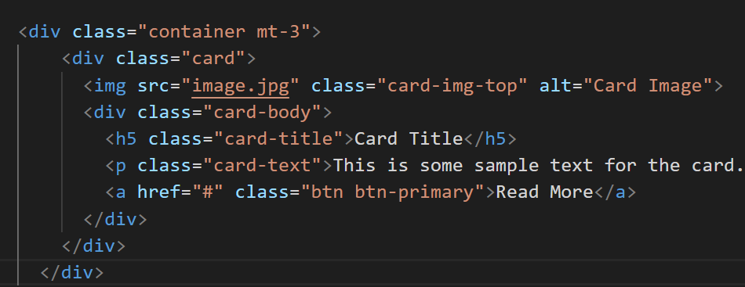

**§--------------------Complete----------------------§**